*1a.* when n = 2, with the given fX(x)

P(y=2) = 0.25

P(y=3) = 0.25

P(y=4) = 0.1875

P(y=5) = 0.125

P(y=6) = 0.078125

P(y=7) = 0.0625

P(y=8) = 0.2734375

P(y=9) = 0.01171875

P(y=10) = 0.0048828125

P(y=11) = 0.0019531250

P(y=12) = 0.0009765625

*1b.*

Base case:

*1c.*

Worst running time: O(n^2)

The 7 parameters:

50 0.5 0.25 0.125 0.0625 0.03125 0.03125

Output:

Min probabilities:

300 5.527e-76

299 2.764e-74

298 7.323e-73

297 1.365e-71

296 2.006e-70

295 2.471e-69

294 2.651e-68

293 2.539e-67

292 2.213e-66

291 1.779e-65

Max probabilities:

97 0.04381

98 0.0438

96 0.04329

99 0.04327

100 0.04226

95 0.04225

101 0.0408

94 0.04071

102 0.03896

93 0.03871

Mean is 98.44

Variance is 82.76

1d.

plot(seq(50,300),h_Y_50, ylab='probability')

par(new=TRUE)

plot(seq(50,300),g_Y_50,type = 'l',col = 'red',xaxt ='n',yaxt = 'n',ylab='',xlab='')

par(new=TRUE)

plot(seq(50,300),f_Y_50,type = 'l',col = 'blue',xaxt ='n',yaxt = 'n',ylab='',xlab='')

legend('topright' ,legend = c('h_Y','g_Y','f_Y'),col = c('black','red','blue') )

In h_Y, var = 82.76

In g_Y, (negative binomial model), var = 95.361328125

In f_Y, (normal distribution), var = 82.763671875



1e.

Exact p value:

In the dynamic modeling, as calculated above

P(y>=300) = p(y = 300) = 5.527e-76

In negative binomial model:

pnbinom(249,50,phi,lower.tail = F) = 2.485516e-35

in normal distribution:

pnorm(299,f_mu,sqrt(var_f),lower.tail = F) = 5.217155e-108

P_true – Pnbinom = -2.485516e-35

P_true – pnorm = 5.527e-76

Normal distribution decays fastest when away from mu. Can be calculated with first derivative of both negative normal distribution density function and normal distribution density function.

Pset 2

2a.

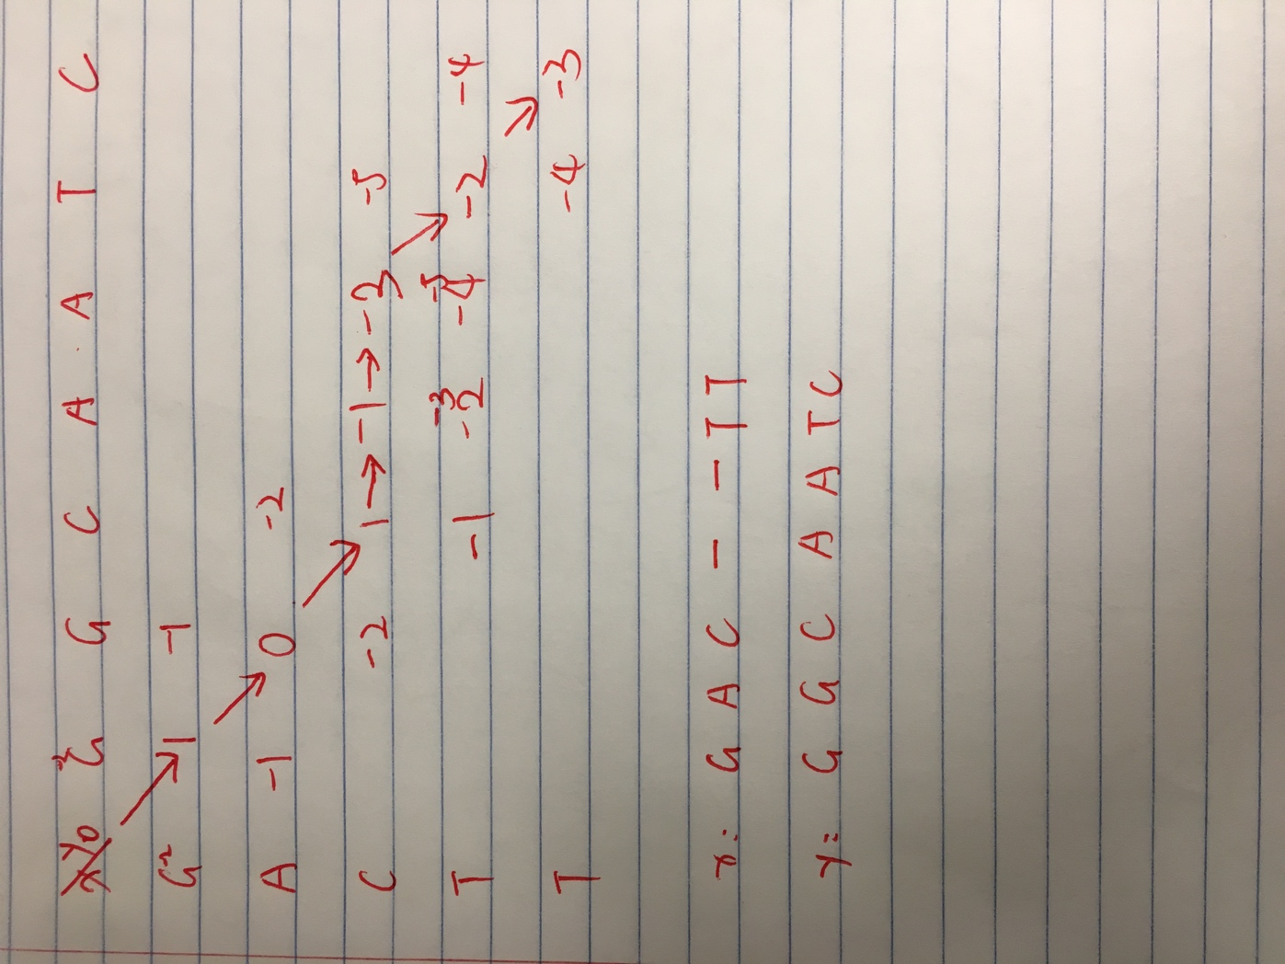

2b.

test on the sequence.fasta

D = 100

Alignment:

GGGTGGGAAA-ATAGACCAATAGG-CAGAGAGAGTCAGTGCCTATCAGAAACCCAAGAGTCTTCTCTGTCTCCACA-TGC

AAA-GGGAAACATAGA-CAG-GGGACACTCAAAGTTAGTGCCTGCTGGAAA-GC-AGA--C--CTCTGTCTCCA-AGCAC

CCAGTTTCTA-TTGGTCTCCTTAAACCTGTCTTGTAACCTTGATA

CCAACTTCTACTT-G------TGAG-CTGCCTTGTAACCTGGATA

Score: 4225

2c.

D = 430 , e = 30

Alignment:

GGGTGGGAAAATAGACCAATAGGCAGAGAGAGTCAGTGCCTATCAGAAACCCAAGAGTCTTCTCTGTCTCCACATGCCCA

AAAGGGAAACATAGA-CAGGGGACACTCAAAGTTAGTGCCTGCTGGAAA-GC---AGA--CCTCTGTCTCCAAGCACCCA

GTTTCTATTGGTCTCCTTAAACCTGTCTTGTAACCTTGATA

ACTTCTACTTG------T-GAGCTGCCTTGTAACCTGGATA

Score: 3077

2d.

Expensive gap:

D = 4300, e = 300

Alignment:

GGGTGGGAAAATAGACCAATAGGCAGAGAGAGTCAGTGCCTATCAGAAACCCAAGAGTCTTCTCTGTCTCCACATGCCCA

--------------AAAGGGAAACATAGACAGGGGACACTCAAAGTTAGTGCCTGCTGGAAAGCAGACCTCTGTCTCCAA

GTTTCTATTGGTCTCCTTAAACCTGTCTTGTAACCTTGATA

GCACCCAACTTCTACTTGTGAGCTGCCTTGTAACCTGGATA

Score: -5288

Cheap gap:

D = 43 e=3

Alignment:

--GGGTGGGAAA-ATAGACCAATA--GG-CA---GAGAGAGTCAGTGCCTATC-AGAAA-CCCAAGAGTCTTCTCTGTCT

AAAG---GGAAACATAGA-C---AGGGGACACTC-A-A-AGTTAGTGCCTG-CTGGAAAGC---AGA--C--CTCTGTCT

CC-A-CATGCCCAGTTTCTA-TTGGTCTCCTTAAACCTGTCTTGTAACCTT-GATA

CCAAGCA--CCCAACTTCTACTT-G------TGAG-CTGCCTTGTAACC-TGGATA

Score: 6643

Evaluate the gap penalty with the true alignment by MLE.

That is to maximize the score with the given sequence based on the parameter D and e.